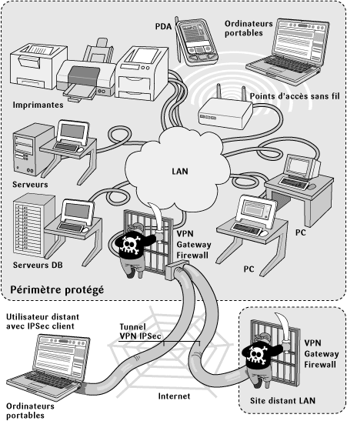
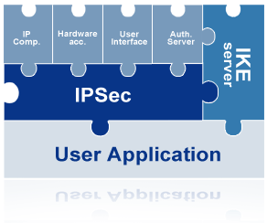

Last update August 2005

The Anatomy of

Microsoft Windows 2003

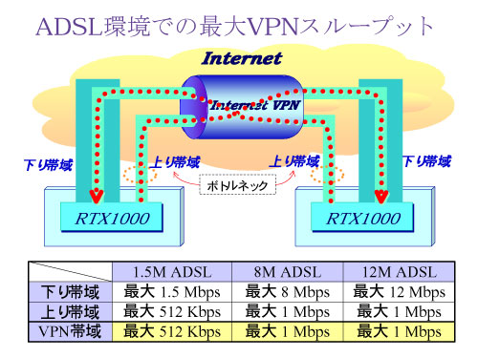
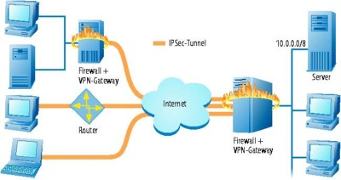
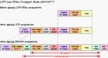
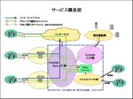
IPSec

The Anatomy of IPSec

Introduction 3
Microsoft IPSec Architecture 3
Windows Server 2003 IPSec Architecture Diagram 3
IPSec Components 3
Policy Agent Architecture 4
Policy Agent Architecture Diagram 4
Policy Agent Components 4
Policy store 5
Policy Agent 5
Policy Agent Service Retrieving and Delivering IPSec Policy Information 5
Local registry 6
Local cache 6
Interface Manager 7
IKE Module Architecture 7
IKE Module Architecture Diagram 7
IKE Module Components 8
IPSec Driver Architecture 8
IPSec Driver Architecture Diagram 9
IPSec Driver Components 9
Assigning IPSec policy 9
Policies stored in Active Directory 9
Important Considerations when assigning an IPSec policy in Active Directory 10
IPSec Deployment Checklist 11
Supporting Lab Work 12
Conclusion 13

Introduction

This document focuses solely on the anatomy of IPSec. What this document does not cover is the logical architecture of IPSec, which is comprised of IPSec protocols, security associations, algorithms, and methodologies. The purpose of this document is to provide system administrators with a comprehensive understanding of how IPSec policies are implemented and used by various components of the Microsoft IPSec architecture. After studying this document a systems administrator should have a thorough understanding of the following:

- The components that comprise the Microsoft IPSec Architecture
- How the components of the IPSec Architecture interact
- Where IPSec policies are stored in a domain.
- How IPSec policies are propagated in a domain.
- Proper methods for importing, assigning, and refreshing IPSec policy in a domain.
- System services that support the IPSec architecture.

Microsoft IPSec Architecture

Windows Server 2003 IPSec Architecture Diagram
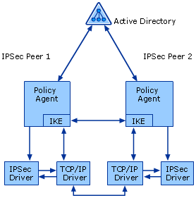

IPSec Components
Component | Description
Active Directory | Windows Server 2003 Active Directory stores domain-wide IPSec policies for computers that are members of the domain. Active Directory-based IPSec policies are polled and retrieved by the Policy Agent.
Policy Agent | The Policy Agent retrieves IPSec policy from an Active Directory domain, a configured set of local policies, or a local cache. The Policy Agent then distributes authentication and security settings to the IKE component and the IP filters to the IPSec driver.
IKE | IKE receives authentication and security settings from the Policy Agent and waits for requests to negotiate IPSec SAs. When requested by the IPSec driver, IKE negotiates both kinds of SAs (main mode and quick mode) with the appropriate endpoint requested by the IPSec driver based on the policy settings obtained from the Policy Agent. After negotiating an IPSec SA, IKE sends the SA settings to the IPSec driver.
IPSec driver | The IPSec driver monitors and secures outbound unicast IP traffic and monitors, decrypts, and validates inbound unicast IP traffic. After the IPSec driver receives the filters from the Policy Agent, it determines which packets are permitted, which are blocked, or which are secured. For secure traffic, the IPSec driver either uses active SA settings to secure the traffic or requests that new SAs be created. The IPSec driver is bound to the TCP/IP driver to provide IPSec processing for IP packets that pass through the TCP/IP driver.
TCP/IP driver | The TCP/IP driver is the Windows Server 2003 implementation of the TCP/IP protocol. It is a kernel-mode component that is loaded from the tcpip.sys file during startup.

The architecture of the Policy Agent, IKE protocol, and IPSec driver are described in more detail in the following sections.

Policy Agent Architecture
The Policy Agent retrieves IPSec policy information, handles the internal interpretation and processing of the policy, and sends it to the other IPSec components that require the information to perform security services. The Policy Agent has the following components: policy store, Policy Agent service, local registry, local cache, and Interface Manager.

Policy Agent Architecture Diagram
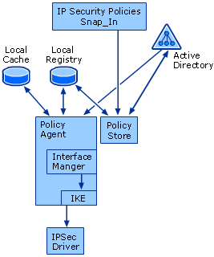

Policy Agent Components
Component | Description
Policy store | The IPSec policy store maintains both IPSec policy descriptions and interfaces to applications and other tools that provide policy data management. The policy store accesses IPSec policy data that is stored in either the local registry or in Active Directory.
Policy Agent | The IPSec Policy Agent controls the retrieval and distribution of IPSec policy and maintains the data about the configured policy for the IPSec driver and IKE.
Local registry | The local registry stores the locally configured IPSec policies, the local cache, and other IPSec settings.
Local cache | The local cache stores IPSec policies after the Policy Agent downloads them from an Active Directory domain controller.
Interface Manager | Interface Manager manages a list that contains items that correspond to each physical and logical network adapter on the system.

The following sections provide additional detail about each of these components.

Policy store
The policy store organizes IPSec policy data and stores it in a format that the Policy Agent can use. In Windows Server 2003, policy data can be stored in the following:
- Active Directory
- Local and remote registry
- A file (for exporting and importing only)
In addition to providing an interface that UI services can use to store policy in each of these media, the policy store does the following:
- Provides policy data for default IPSec policies
- Checks policy information for consistency
- Retrieves policy version information
The policy store reads and writes policy information both to and from persistent storage and is aware of shared policy-setting dependencies. This ensures that all policies using shared settings are marked as changed when they are modified and that Windows Server 2003 IPSec components download the modified policies.

Policy Agent
The Policy Agent retrieves IPSec policy information and delivers it to other IPSec components that require this information to perform security services, as shown in the following illustration.

Policy Agent Service Retrieving and Delivering IPSec Policy Information

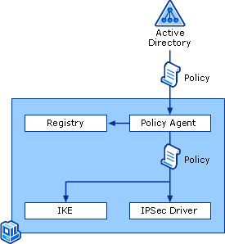

The Policy Agent performs the following tasks:
- Retrieves the appropriate IPSec policy (if one has been assigned) from Active Directory if the computer is a domain member or from the local registry if the computer is not a member of a domain
- Determines filter list order
- Delivers the assigned IPSec policy information (IP filters) to the IPSec driver
- Delivers both main mode and quick mode settings to IKE
- Polls for changes in policy configuration. If the computer is a member of a domain, policy retrieval occurs when the computer starts, at the interval specified in the IPSec policy, and at the default Winlogon polling interval. You can also manually poll Active Directory for policy by using the gpupdate /target:computer command.
If there are no IPSec policies in Active Directory or the registry, or if the IPSec Policy Agent cannot connect to Active Directory, the IPSec Policy Agent waits for policy to be assigned or activated.
The Policy Agent appears in the list of computer services in the Services snap-in under the name IPSEC Services and starts automatically as part of the initialization of the Local Security Authority (LSA) service.

Local registry
Each computer running Windows XP or a Windows Server 2003 has only one local Group Policy object, often called the local computer policy. Using this local Group Policy object allows Group Policy settings to be stored on individual computers regardless of whether they are members of an Active Directory domain.
The local registry maintains the IPSec policy configuration in the following registry key and its subkeys: HKEY_LOCAL_MACHINE\Software\Policies\Microsoft\Windows\IPSec.
If you assign local IPSec policies and you do not assign Active Directory-based IPSec policies, the local policies are stored in the following registry key: HKEY_LOCAL_MACHINE\Software\Policies\Microsoft\Windows\IPSec\Policy\Local.
If you assign Active Directory-based IPSec policies, the policies are read from Active Directory and stored in the local cache.

Local cache
The local cache is part of the registry. If you assign an IPSec policy in Active Directory, the policy is stored in and read from Active Directory. A copy of the current policy in Active Directory is maintained in a cache in the local registry at: HKEY_LOCAL_MACHINE\Software\Policies \Microsoft\Windows\IPSec\Policy\Cache.
If a computer to which an IPSec policy in Active Directory is assigned cannot connect to the domain, the cached copy of the policy in Active Directory is applied. When the computer reconnects to the domain, new policy information for that computer replaces old, cached information. You cannot configure or manage the cached copy of an IPSec policy in Active Directory.

Interface Manager
Interface Manager maintains a list of physical and logical network adapters on the computer and notifies the Policy Agent when interface and address changes occur. Interface Manager also maintains a complete list of generic filters. Generic filters are filters that are configured to use My IP Address either as a source address or as a destination address. Generic filters are saved in the appropriate IPSec policy storage location with either a source address or a destination address of 0.0.0.0 and a corresponding subnet mask of 255.255.255.255.

IKE Module Architecture
The IKE module receives authentication and security settings from the Policy Agent and waits for requests to negotiate SAs. When the IKE module receives a request to negotiate an SA from the IPSec driver, the IKE module negotiates both kinds of SAs (the main mode SA and the quick mode SA) with the appropriate endpoint based on the request of the IPSec driver that the policy settings obtained from the Policy Agent. After it has negotiated an SA, the IKE module sends the SA settings to the IPSec driver.
The IKE module has the following components:
- CryptoAPI
- Diffie-Hellman Cryptographic Service Provider (CSP)
- RSA CSP
- Certificate store
- Security Support Provider Interface (SSPI)
- Kerberos Security Support Provider (SSP)

IKE Module Architecture Diagram
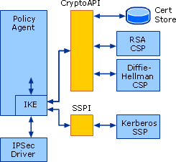
- A cryptographic service provider (CSP) is an independent software module that provides implementations of cryptographic standards and algorithms. The CSP carries out the cryptographic functions of CrytoAPI, creating keys, destroying them, and using them to perform a variety of cryptographic operations.

IKE Module Components
Component | Description
CryptoAPI | CryptoAPI provides a set of functions that allows applications based on Windows to encrypt or digitally sign data in a flexible manner while providing protection for the user's sensitive private key data. Independent modules known as CSPs perform actual cryptographic operations.  The IKE negotiation must be encrypted. This encryption is limited by what can be configured in IPSec policy. The standard CryptoAPI functions for keyed hashing (using HMAC-MD5 and HMAC-SHA1) and data encryption (using DES and 3DES) are used
Diffie-Hellman CSP | The Diffie-Hellman CSP contains the implementation of the Diffie-Hellman key exchange and determination algorithm. IKE uses only the Microsoft Base or Enhanced CSP for Diffie-Hellman. However, the Diffie-Hellman calculation can be accelerated using the CryptoAPI exponentiation offload interface (OffloadModExpo), as documented in the CryptoAPI SDK.
RSA CSP | The RSA CSP contains the implementation of the Rivest-Shamir-Adleman (RSA) cryptographic algorithms. When certificate authentication is selected, IKE checks the CryptoAPI default provider to see if it is capable of performing RSA 512-bit digital signatures. If so, then IKE uses this default CSP. If not, IKE enumerates the RSA providers, selects hardware-based providers first and ensures that they can provide 512-bit signatures. IKE performs these actions to open the certificate store.  The certificate selected during the IKE negotiation specifies the CSP that is used for signature operations during IKE negotiation; the certificates associated CSP for the private key signature is used. As long as the RSA CSP supports the NOHASHID flag for the CryptSignHash( ) API call, IKE can use that CSP for private key signing of IKE payloads. Because the enumeration process does not permit IKE to know if the CSP supports the NOHASHID option, it is possible to choose a certificate that appears valid, but whose CSP does not allow IKE to construct the proper signature.
Certificate store | The certificate store is a permanent storage location where certificates, certificate revocation lists, and certificate trust lists are stored. The certificate store is a physical store on the Windows Server 2003 computer, but it is viewed logically as belonging to the user account of the currently logged-on user, a service account, or the computer account. IKE can use only the computer account, usually referred to as the computer store. You can view the computer store by using the Certificates snap-in.
SSPI | The SSPI enables network applications to access one of several security providers to establish authenticated connections and exchange data securely over those connections.
Kerberos SSP | The Kerberos SSP contains an implementation of the Kerberos security protocol. The Kerberos SSP is an SSPI provider

IPSec Driver Architecture
The IPSec driver is a kernel-mode component that monitors and secures IP packets. In addition to the Policy Agent and IKE, the IPSec driver uses the following components: the Security Association Database (SAD), the Security Policy Database (SPD), the TCP/IP driver, TCP/IP applications, and the network interface.
The IPSec driver matches IP packet information with the IP filters that are configured in the active SPD. If traffic must be secured, the IPSec driver either uses the appropriate SA to determine how to provide packet security or requests that the IKE module negotiate SAs to be used to provide packet security. After the IPSec driver determines which SA to use, it creates and validates encrypting, decrypting, and hashing to create or interpret the AH and ESP headers on an IPSec-protected packet.
The following figure shows the IPSec driver architecture and how the driver interacts with other components in Windows Server 2003.

IPSec Driver Architecture Diagram
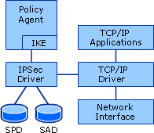

IPSec Driver Components
Component | Description
SAD | The SAD is a database in the IPSec driver that contains the parameters associated with each active SA. This database is populated automatically from the IKE module.
SPD | The SPD is a database in the IPSec driver that specifies the filter lists and associated settings that determine the status of all inbound or outbound IP traffic. Inbound packets are checked to ensure that they have been secured according to policy. Outbound packets are permitted, blocked, or secured, according to policy. For secured traffic, the security policy that is used is the negotiated SA, which is stored in the SAD.
TCP/IP driver | The TCP/IP driver is the Windows Server 2003 implementation of the TCP/IP protocol. It is a kernel-mode component that is loaded from the Tcpip.sys file during startup.
TCP/IP applications | TCP/IP applications use TCP/IP and access TCP/IP network services through an appropriate network API, such as Windows Sockets, NetBIOS, or Remote Procedure Call (RPC).
Network interface | The network interface is the logical or physical interface over which IP packets are sent and received. The details of the Network Driver Interface Specification (NDIS) interface, the network adapter driver, and the physical media over which the IP packets are sent and received are beyond the scope of this subject.

Assigning IPSec policy
IPSec policy can be created and modified using the IP Security Policies snap-in that is available in Microsoft Management Console (MMC). It can manage policy centrally (for Active Directory clients), locally (on the computer on which you are running the snap-in), or remotely for a computer or domain. You can use the IP Security Policies snap-in to manage both local computer and domain policy.
- To assign IPSec policy in Active Directory, you must use Group Policy.

Policies stored in Active Directory
A Group Policy object defines access, configuration, and usage settings for accounts and resources. IPSec policies can be assigned to a Group Policy object of a site, domain, or organizational unit. When the IPSec policy is imported and assigned to a Group Policy object for an Active Directory object, the IPSec policy is propagated to any computer accounts that are affected by that Group Policy object.

Important Considerations when assigning an IPSec policy in Active Directory
- The list of all IPSec policies is available to assign at any level in the Active Directory hierarchy. However, only a single IPSec policy can be assigned at a specific level in Active Directory.
- IPSec policies that are configured and assigned for the domain take precedence over the local, active IPSec policy when that computer is a member of the domain.
- IPSec policies that are assigned to organizational units in Active Directory take precedence over domain level policy for any members of that organizational unit.
- An organizational unit inherits the policy of its parent organizational unit unless either policy inheritance is explicitly blocked or policy is explicitly assigned.
- IPSec policies from different organizational units are never merged.
- The highest possible level of the Active Directory hierarchy should be used to assign policies to reduce the amount of configuration and administration required.
- An IPSec policy might remain active even after the Group Policy object to which it is assigned has been deleted. Because of this, you should unassign the IPSec policy before you delete the policy object. To prevent problems, use the following procedure:
  - Unassign the IPSec policy in the Group Policy object.
  - Wait 24 hours to ensure that the change is propagated.
  - Delete the Group Policy object.
If you delete the Group Policy object without following this procedure, computers in the Active Directory container to which the IPSec policy is assigned treat the IPSec policy as if it cannot be located and continue to use a cached copy.
- Group Policy backup and restore in Active Directory must also include IPSec policies to ensure consistency.
The IPSec Policy Agent on a computer running Windows polls Active Directory for updates to the assigned IPSec policy. This polling does not detect a change in domain or organizational unit membership or the assigning or unassigning of a new policy. These events are detected when the Winlogon service polls for changes in Group Policy, which occurs by default every 90 minutes. The Winlogon service discovers these changes, notifies the IPSec Policy Agent, and the changes are applied.

IPSec Deployment Checklist
To successfully deploy IPSec for Windows Server 2003, you must ensure the following:
- If your scenario requires Active Directory-based IPSec policy (a collection of IPSec rules that determine IPSec behavior), the Active Directory® directory service and Group Policy must be configured correctly on the corporate network, appropriate trusts must be defined, and appropriate permissions must be applied. Although Group Policy applies to both users and computers; IPSec policy is a computer configuration Group Policy setting that applies only to computers.
- Each computer that will establish IPSec-secured communications must have an IPSec policy assigned. This policy must be compatible with the IPSec policy that is assigned to other computers with which that computer must communicate.
- Authentication must be configured correctly and an appropriate authentication method must be specified in the IPSec policy so that mutual authentication can occur between IPSec peers.
- Routers, firewalls, or other filtering devices must be configured correctly to permit IPSec protocol traffic on all parts of the corporate network, if IPSec negotiation messages and IPSec-secured traffic must pass through these devices.
- Computers must run operating systems that automatically support IPSec or must have appropriate client software installed.
- If computers are running different versions of the Microsoft Windows® operating system (for example, Windows Server 2003, the Microsoft Windows XP operating system, and the Microsoft Windows 2000 operating system), you must address the compatibility of the IPSec policies.
- If clients must establish IPSec-secured connections with servers, those servers must be adequately sized to support those connections. If necessary, you can use IPSec hardware offload network adapters.
- The numbers of IPSec policies are kept to a minimum, and the IPSec policies are made as simple as possible.
- Systems administrators who will configure and support IPSec must be properly trained and must be members of the appropriate administrative groups.

Supporting Lab Work

Lab setup: Single domain controller, Default IPSec policies on Local Host and Active Directory.

- Create an IPSec Policy called “Test Policy” using the IP Security Policies on Active Directory snap-in. This process writes the new IPSec policy to the Active Directory policy store.

- Create a new GPO on the Domain Controllers OU and assign the “Test Policy” created in step #1. The “Test Policy” is available for assignment in the new GPO because the IP Security Policies node of the GPO is connected by default to the Active Directory policy store of the current domain.

- Inspect the registry at: HKEY_LOCAL_MACHINE\Software\Policies \Microsoft\Windows\IPSec\Policy. The “Cache” registry branch is conspicuously absent as no policies have been read from Active Directory yet although an assigned policy for this machine exists.

- Execute a gpupdate /force and inspect the registry again. This time the “Cache” registry branch as been created and the details of the assigned policy can be observed. Note the following details about our policy which has been read from Active Directory by the policy store and written to the local cache:

name: ipsecPolicy{298d1349-9106-4074-80e8-0ab25a82fedc}
ipsecName: Test Policy
ipsecID: {298d1349-9106-4074-80e8-0ab25a82fedc}
whenChanged: 40a33014

- When we look at the registry, we see that the policy is created with its own unique identity value stored in the key “ipsecID”. It has a “time stamp” stored in the key “whenChanged” in hex. If we export this policy, and open it in a text editor, although barely legible, we can see the registry paths mapping back to the unique ID’s. These unique ID’s also correlate directly to specific locations in the Active Directory policy store. What does this mean to us? When an existing IPSec policy is exported, modified, then distributed to the child domains to be re-imported, we are assured the new modified settings are mapping back directly to the original policy object in the policy store and overwriting the values.

- To demonstrate this, the original “Test Policy” was exported. A new rule was added with a new filter, and the policy was re-imported. After executing a gpupdate /force the policy was inspected to verify that the modifications were now present in Active Directory. When inspecting the registry we note the “whenChanged” key has a new value:

name: ipsecPolicy{298d1349-9106-4074-80e8-0ab25a82fedc}
ipsecName: Test Policy
ipsecID: {298d1349-9106-4074-80e8-0ab25a82fedc}
whenChanged: 40a34466

When the IPSec policy agent polls Active Directory and detects a version change to an assigned IPSec policy by looking at the “whenChanged” key, the policy store will download the new data from Active Directory to the local cache in the registry. The IPSec policy agent will then pass the new policy data to the IPSec driver and IKE.

Conclusion

When the importation of an IPSec policy template modifies existing assigned policies in Active Directory, the changes will take effect with no other action as soon as one of the following occurs: The computer starts/re-starts, when the “Check for changes” interval specified in the IPSec policy is reached, when the default Winlogon polling interval (90 minutes) is reached, or if Active Directory is manually polled via either the gpupdate /force or gpupdate /target:computer command.

